PRACTICAL 3

**Table Name: PRODUCT_MASTER**

|  |  |  |
| --- | --- | --- |
| **COLUMN NAME** | **DATA TYPE** | **SIZE** |
| PRODUCTNO | VARCHAR2 | 6 |
| DESCRIPTION | VARCHAR2 | 15 |
| PROFITPERCENT | NUMBER | 4,2 |
| UNITMEASURE | VARCHAR2 | 10 |
| QTYONHAND | NUMBER | 8 |
| REORDERLVL | NUMBER | 8,2 |
| SELLPRICE | NUMBER | 8,2 |
| COSTPRICE | NUMBER | 8,2 |

**Insert the following values in PRODUCT_MASTER**

|  |  |  |  |  |  |  |  |
| --- | --- | --- | --- | --- | --- | --- | --- |
| PRODUCTNO | DESCRIPTION | PROFIT  PERCENT | UNIT  MEASURE | QTYON  HAND | REORDER  LVL | SELL  PRICE | COST  PRICE |
| P00001 | T-Shirts | 5 | Piece | 200 | 50 | 350 | 250 |
| P0345 | Shirts | 6 | Piece | 150 | 50 | 500 | 350 |
| P06734 | Cotton Jeans | 5 | Piece | 100 | 20 | 600 | 450 |
| P07865 | Jeans | 5 | Piece | 100 | 20 | 750 | 500 |
| P07868 | Trousers | 2 | Piece | 150 | 50 | 850 | 550 |
| P07885 | Pull Overs | 2.5 | Piece | 80 | 30 | 700 | 450 |
| P07965 | Denim Shirts | 4 | Piece | 50 | 55 | 350 | 250 |
| P07975 | Lycra Tops | 5 | Piece | 70 | 75 | 300 | 175 |
| P08865 | Skirts | 5 | Piece | 75 | 30 | 450 | 300 |

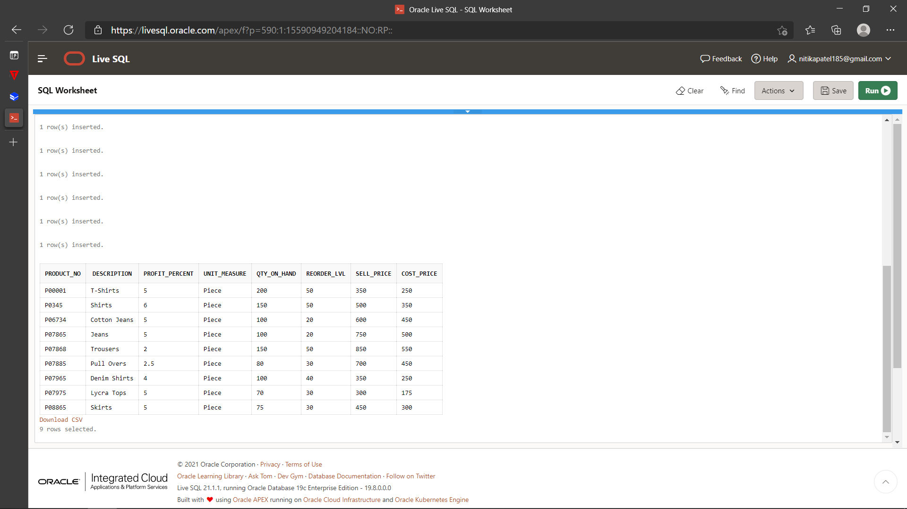

**Write & Execute SQL Queries for the following:**

1. Retrieve the contents of the column product_no, description and compute 5% of the values contained in the column sell_price and rename it as “Increase” and 6% of the values contained in the field cost_price and rename it as “New Price” for each row from the table product_master.
2. Retrieve the contents of the columns product no, description, profit percent, sell price from the table product_master where the values contained in the field profit_percent is between 10 and 20 both inclusive.
3. List all the products whose QTY_ON_HAND is less than REORDER_LVL.
4. List the Product Description whose SELL_PRICE is less than 500.
5. List the Product_No whose DESCRIPTION starts with letter 'S'.
6. List the Product_No whose DESCRIPTION ends with letter 's'.
7. List the description of product whose SELL_PRICE is in range of 300, 350 or 450.
8. List the description of product whose SELL_PRICE is NOT in range of 300, 350 or 450.

CREATE TABLE PRODUCT_MASTER

(PRODUCT_NO VARCHAR2(7), DESCRIPTION VARCHAR2(15), PROFIT_PERCENT NUMBER(4,2), UNIT_MEASURE VARCHAR2(10), QTY_ON_HAND NUMBER(8), REORDER_LVL NUMBER(8,2), SELL_PRICE NUMBER(8,2), COST_PRICE NUMBER(8,2));

DESC PRODUCT_MASTER

INSERT INTO PRODUCT_MASTER

VALUES('P00001', 'T-Shirts', 5, 'Piece', 200, 50, 350, 250);

INSERT INTO PRODUCT_MASTER

VALUES('P0345', 'Shirts', 6, 'Piece', 150, 50, 500, 350);

INSERT INTO PRODUCT_MASTER

VALUES('P06734', 'Cotton Jeans', 5, 'Piece', 100, 20, 600, 450);

INSERT INTO PRODUCT_MASTER

VALUES('P07865', 'Jeans', 5, 'Piece', 100, 20, 750, 500);

INSERT INTO PRODUCT_MASTER

VALUES('P07868', 'Trousers', 2, 'Piece', 150, 50, 850, 550);

INSERT INTO PRODUCT_MASTER

VALUES('P07885', 'Pull Overs', 2.5,'Piece', 80, 30, 700, 450);

INSERT INTO PRODUCT_MASTER

VALUES('P07965', 'Denim Shirts', 4, 'Piece', 100, 40, 350, 250);

INSERT INTO PRODUCT_MASTER

VALUES('P07975', 'Lycra Tops', 5, 'Piece', 70, 30, 300,175);

INSERT INTO PRODUCT_MASTER

VALUES('P08865', 'Skirts', 5, 'Piece', 75, 30, 450, 300);

SELECT * FROM PRODUCT_MASTER;

SELECT PRODUCT_NO,DESCRIPTION, SELL_PRICE*0.05 "INCREASE",COST_PRICE*0.05 "NEWPRICE" FROM PRODUCT_MASTER;

SELECT PRODUCT_NO,DESCRIPTION,PROFIT_PERCENT,SELL_PRICE FROM PRODUCT_MASTER WHERE PROFIT_PERCENT BETWEEN 2 AND 5;

SELECT DESCRIPTION,PRODUCT_NO FROM PRODUCT_MASTER WHERE SELL_PRICE < 500;

SELECT PRODUCT_NO FROM PRODUCT_MASTER WHERE DESCRIPTION LIKE 'S%';

SELECT PRODUCT_NO FROM PRODUCT_MASTER WHERE DESCRIPTION LIKE 's%';

SELECT DESCRIPTION FROM PRODUCT_MASTER WHERE SELL_PRICE IN (300,350,450);

SELECT DESCRIPTION FROM PRODUCT_MASTER WHERE SELL_PRICE NOT IN (300,350,450);

1. **Retrieve the contents of the column product_no, description and compute 5% of the values contained in the column sell_price and rename it as “Increase” and 6% of the values contained in the field cost_price and rename it as “New Price” for each row from the table product_master.**

**2.Retrieve the contents of the columns product no, description, profit percent, sell price from the table product_master where the values contained in the field profit_percent is between 10 and 20 both inclusive**

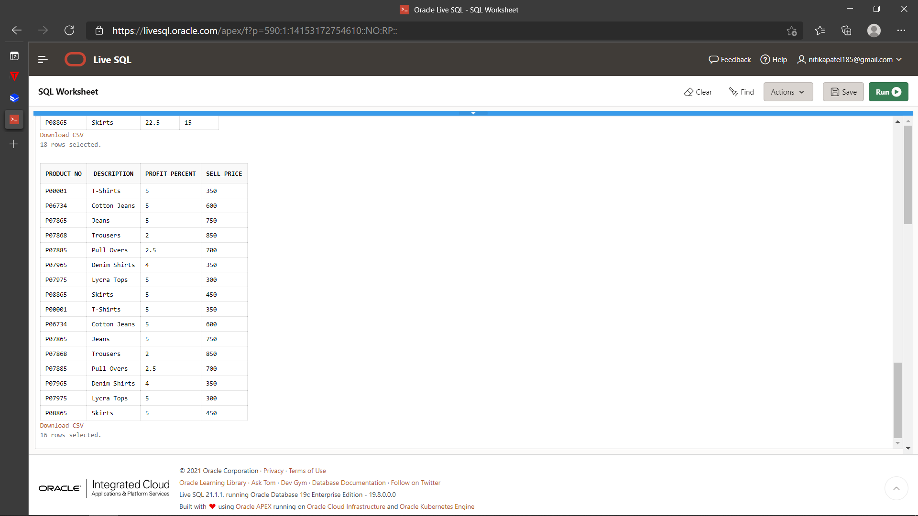

**3.List all the products whose QTY_ON_HAND is less than REORDER_LVL.**

SELECT * FROM PRODUCT_MASTER WHERE QTY_ON_HAND < REORDER_LVL;

**4.List the Product Description whose SELL_PRICE is less than 500.**

1. **List the Product_No whose DESCRIPTION starts with letter 'S'.**

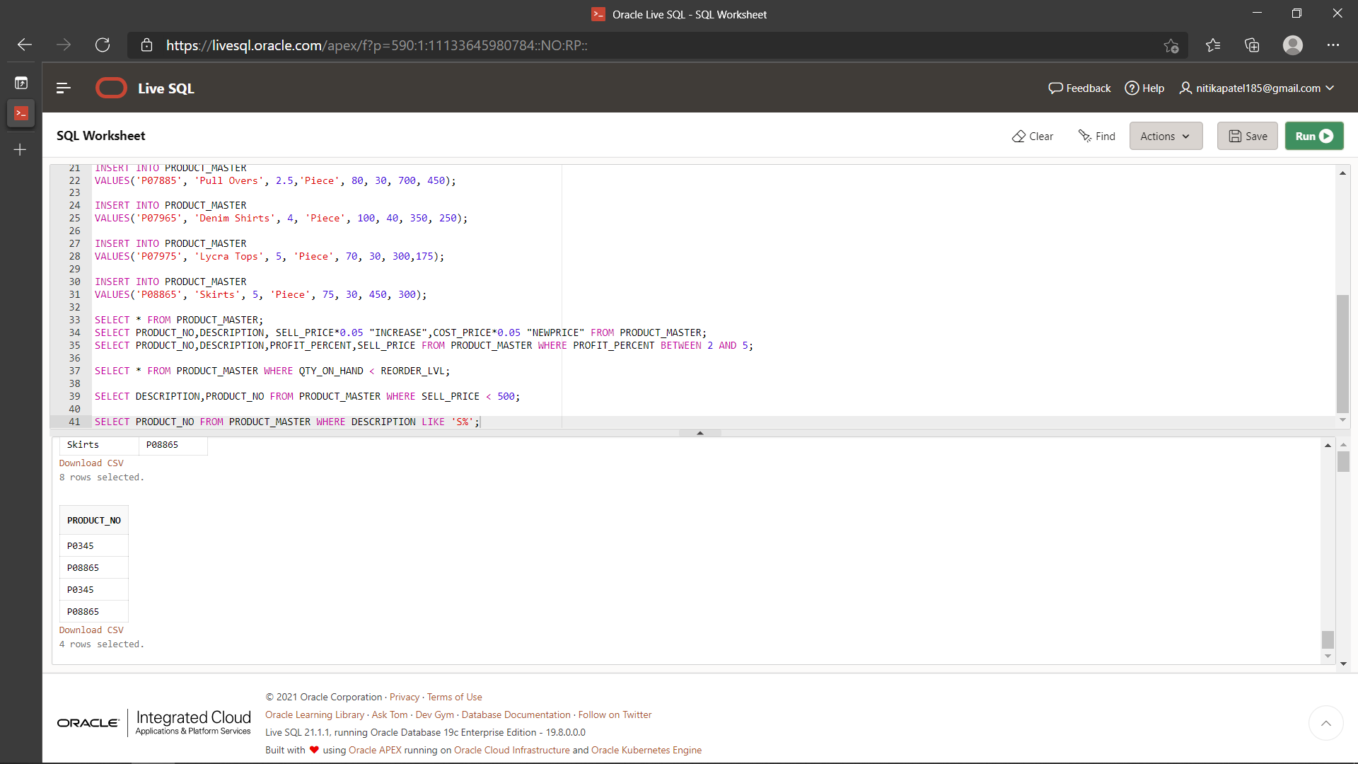

1. **List the Product_No whose DESCRIPTION ends with letter 's'.**

1. **List the description of product whose SELL_PRICE is in range of 300, 350 or 450**.

1. List the description of product whose SELL_PRICE is NOT in range of 300, 350 or 450.

